https://www.linkedin.com/in/aritrakarmakar7/ -- profile

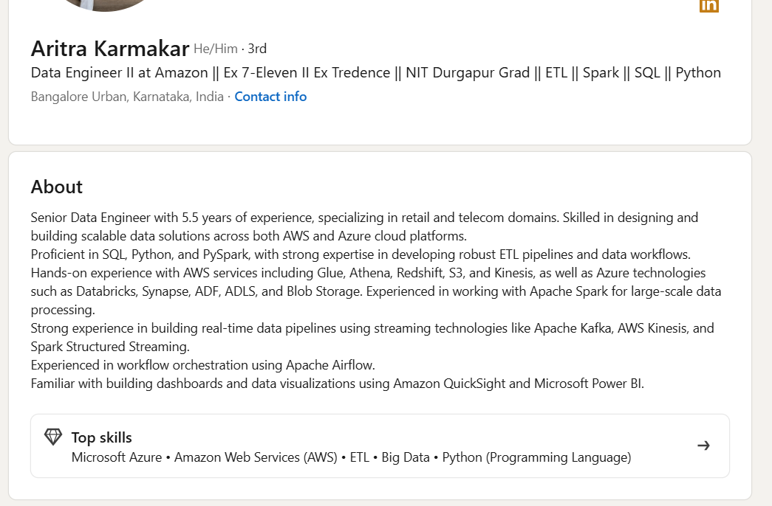

Senior Data Engineer with 5.5 years of experience, specializing in retail and telecom domains. Skilled in designing and building scalable data solutions across both AWS and Azure cloud platforms.
Proficient in SQL, Python, and PySpark, with strong expertise in developing robust ETL pipelines and data workflows.
Hands-on experience with AWS services including Glue, Athena, Redshift, S3, and Kinesis, as well as Azure technologies such as Databricks, Synapse, ADF, ADLS, and Blob Storage. Experienced in working with Apache Spark for large-scale data processing.
Strong experience in building real-time data pipelines using streaming technologies like Apache Kafka, AWS Kinesis, and Spark Structured Streaming.
Experienced in workflow orchestration using Apache Airflow.
Familiar with building dashboards and data visualizations using Amazon QuickSight and Microsoft Power BI.

    - 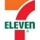
Senior Data Engineer at 7-Eleven

    - 
Data Engineer at Tredence Inc.

    - 
Full Stack Analyst Internship at Tredence Inc.

1 endorsement

- Amazon Web Services (AWS)

    - 
Data Engineer 2 at Amazon

Endorsed by 1 person in the last 6 months

1 endorsement

- ETL

    - 
Senior Data Engineer at 7-Eleven

Endorsed by 1 person in the last 6 months

1 endorsement

- Big Data
- Python (Programming Language)

For a Data Engineer with 3 years of experience, you should focus on:
- SQL (Advanced queries, optimization)
- Python (Data processing, coding)
- ETL/ELT concepts
- Data Warehousing
- Databases
- Spark basics
- Cloud concepts (AWS/Azure/GCP basics)
- Data Modeling
Here are interview questions with expected answers:

SQL Questions

1. Difference between WHERE and HAVING?
Answer:
WHERE | HAVING
Filters rows before aggregation | Filters groups after aggregation
Cannot use aggregate functions | Can use aggregate functions
Example:
SELECT dept_id, COUNT(*)
FROM employees
WHERE salary > 50000
GROUP BY dept_id
HAVING COUNT(*) > 5;

2. Find the 2nd highest salary.

Method 1
SELECT MAX(salary)
FROM employees
WHERE salary < (
SELECT MAX(salary)
FROM employees
);

Method 2
SELECT salary
FROM (
SELECT salary,
DENSE_RANK() OVER (ORDER BY salary DESC) rnk
FROM employees
) t
WHERE rnk = 2;

3. Difference between RANK(), DENSE_RANK(), and ROW_NUMBER()
Sample Data:
Salary
100
100
90
Result:
Salary | Rank | Dense_Rank | Row_Number
100 | 1 | 1 | 1
100 | 1 | 1 | 2
90 | 3 | 2 | 3
Answer:
- ROW_NUMBER → Unique numbering.
- RANK → Skips numbers.
- DENSE_RANK → No gaps.

4. What is a CTE?
Answer:
Common Table Expression.
WITH high_salary AS (
SELECT *
FROM employees
WHERE salary > 100000
)
SELECT *
FROM high_salary;
Benefits:
- Readability
- Recursive queries
- Reusability

5. Difference between DELETE, TRUNCATE, and DROP
DELETE | TRUNCATE | DROP
Removes rows | Removes all rows | Removes table
Can rollback | Depends on DB | Cannot recover easily
WHERE supported | No WHERE | N/A

6. What are indexes?
Answer:
Indexes improve query performance by reducing table scans.
CREATE INDEX idx_emp_name
ON employees(name);
Tradeoff:
- Faster reads
- Slower inserts/updates

7. Explain SQL Joins

INNER JOIN
SELECT *
FROM A
INNER JOIN B
ON A.id=B.id;
Returns matching records.

LEFT JOIN
Returns all rows from left table.

RIGHT JOIN
Returns all rows from right table.

FULL JOIN
Returns all rows from both tables.

8. Find duplicate records.
SELECT email,
COUNT(*)
FROM customers
GROUP BY email
HAVING COUNT(*) > 1;

9. Difference between UNION and UNION ALL
UNION
- Removes duplicates.
UNION ALL
- Keeps duplicates.
- Faster.

10. What is query optimization?
Expected Answer:
- Use indexes.
- Avoid SELECT *.
- Partition large tables.
- Use proper joins.
- Analyze execution plans.

Python Questions

11. Difference between List and Tuple
List | Tuple
Mutable | Immutable
[] | ()
Example:
my_list = [1,2,3]
my_tuple = (1,2,3)

12. What are Python generators?
def numbers():
for i in range(5):
yield i
Benefits:
- Memory efficient.
- Lazy evaluation.

13. Difference between deep copy and shallow copy
import copy

a = [[1,2]]
b = copy.copy(a)
c = copy.deepcopy(a)
- Shallow copy copies references.
- Deep copy copies nested objects.

14. Find duplicate elements in a list.
nums = [1,2,3,2,4,1]

duplicates = set()

seen = set()

for num in nums:
if num in seen:
duplicates.add(num)
else:
seen.add(num)

print(duplicates)
Output:
{1, 2}

15. Reverse a string
s = "uttam"

print(s[::-1])
Output:
mattu

16. Count frequency of words
from collections import Counter

text = "python sql python spark"

print(Counter(text.split()))
Output:
{'python':2,'sql':1,'spark':1}

17. Explain *args and **kwargs
def test(*args):
print(args)

def test2(**kwargs):
print(kwargs)
- *args → Variable positional arguments.
- **kwargs → Variable keyword arguments.

18. What is a decorator?
def decorator(func):
def wrapper():
print("Before")
func()
return wrapper
Used for:
- Logging
- Authentication
- Monitoring

Data Engineering Questions

19. What is ETL vs ELT?

ETL
Source → Transform → Load

ELT
Source → Load → Transform
Modern cloud systems prefer ELT.

20. What is Data Warehouse?
Central repository for analytics.
Examples:
- Snowflake
- Amazon Redshift
- Google BigQuery

21. Fact Table vs Dimension Table

Fact Table
Contains metrics.
sales_amount
quantity
profit

Dimension Table
Contains descriptive attributes.
customer
product
region

22. What is Partitioning?
Large table split into smaller chunks.
Example:
sales_2025
sales_2026
Benefits:
- Faster queries
- Better scalability

23. What is Data Skew?
Uneven data distribution.
Example:
90% records belong to one customer.
Causes:
- Slow Spark jobs
- Uneven processing

24. Explain Slowly Changing Dimensions (SCD)

Type 1
Overwrite old value.

Type 2
Maintain history.
Customer
Version
Start Date
End Date

Type 3
Keep previous value in extra column.

Spark Questions (Very Common for 3 Years)

25. Difference between RDD, DataFrame, Dataset
Expected Answer:
RDD | DataFrame
Low-level | High-level
No optimization | Catalyst optimized
Slower | Faster
Most projects use DataFrames.

26. What are transformations and actions?

Transformations
map()
filter()
select()
Lazy operations.

Actions
collect()
count()
show()
Trigger execution.

27. What is lazy evaluation?
Spark doesn't execute immediately.
Execution starts only when an action is called.

28. What is repartition vs coalesce?

Repartition
- Increase/decrease partitions.
- Full shuffle.

Coalesce
- Usually decrease partitions.
- Less expensive.

Scenario-Based Questions

29. A SQL query that runs in 20 minutes suddenly takes 2 hours. What will you check?
Expected Answer:
- Execution plan
- Missing indexes
- Data growth
- Statistics
- Locks/blocking
- Partition pruning

30. Daily ETL failed. What steps will you take?
Expected Answer:
- Check logs.
- Validate source data.
- Check database connectivity.
- Verify schema changes.
- Re-run failed stage.
- Validate output.

31. How would you process 100 million records?
Expected Answer:
- Use Spark/PySpark.
- Partition data.
- Avoid collecting data to driver.
- Use distributed processing.
- Optimize joins and caching.

These 30+ questions are very close to what companies typically ask a 3-year Data Engineer in service-based companies, product companies, and telecom projects. They cover SQL, Python, Spark, ETL, Data Warehousing, and real-world troubleshooting scenarios.
For Big 4 (Deloitte, EY, PwC, KPMG) and Product Companies (Amazon, Google, Microsoft, Uber, Airbnb, Walmart Global Tech, Atlassian, Adobe, etc.), the expectation from a 3-year Data Engineer is much higher than basic SQL and Python.
They focus heavily on:
- Advanced SQL
- Python coding
- Data Modeling
- Distributed Systems
- Spark Internals
- ETL Design
- Performance Optimization
- Real-world Problem Solving
- System Design for Data Pipelines

SQL (Amazon/Google Level)

Q1: Find the 3rd highest salary without using LIMIT/TOP.
SELECT salary
FROM (
SELECT salary,
DENSE_RANK() OVER(ORDER BY salary DESC) rnk
FROM employees
) t
WHERE rnk = 3;

Follow-up:
Difference between RANK and DENSE_RANK?
Answer:
- RANK skips values.
- DENSE_RANK doesn't skip.

Q2: Find employees earning more than their manager.

Table
employee_id
name
salary
manager_id

Solution
SELECT e.name
FROM employees e
JOIN employees m
ON e.manager_id = m.employee_id
WHERE e.salary > m.salary;

Q3: Identify duplicate records and delete them.
WITH cte AS (
SELECT *,
ROW_NUMBER() OVER(
PARTITION BY email
ORDER BY id
) rn
FROM users
)
DELETE FROM cte
WHERE rn > 1;

Q4: What is the difference between

EXISTS
SELECT *
FROM employees e
WHERE EXISTS (
SELECT 1
FROM departments d
WHERE e.dept_id=d.id
);

IN
SELECT *
FROM employees
WHERE dept_id IN (
SELECT id
FROM departments
);

Expected Answer
For large datasets:
- EXISTS is often faster.
- Stops after first match.
- IN may scan full subquery result.

Q5: How would you optimize this query?
SELECT *
FROM orders
WHERE DATE(order_date)='2026-01-01';
Expected Answer:
Avoid function on indexed columns.
Bad:
DATE(order_date)
Good:
WHERE order_date >= '2026-01-01'
AND order_date < '2026-01-02'

Q6: Find customers who ordered on consecutive days.
WITH cte AS (
SELECT customer_id,
order_date,
LAG(order_date)
OVER(
PARTITION BY customer_id
ORDER BY order_date
) prev_date
FROM orders
)
SELECT *
FROM cte
WHERE DATEDIFF(day,prev_date,order_date)=1;

Python Coding (Amazon Frequently Asked)

Q7: Find first non-repeating character.
from collections import Counter

s="amazon"

count=Counter(s)

for ch in s:
if count[ch]==1:
print(ch)
break
Output:
m

Q8: Find top K frequent elements.
from collections import Counter

nums=[1,1,1,2,2,3]

k=2

result=Counter(nums).most_common(k)

print(result)

Q9: Merge intervals.
Input
[[1,3],[2,6],[8,10]]
Output
[[1,6],[8,10]]
Expected complexity:
O(n log n)

Q10: Detect cycle in linked list.
Expected Answer:
Floyd's Cycle Detection Algorithm.
Slow Pointer
Fast Pointer
Time:
O(n)
Space:
O(1)

Q11: Explain Python GIL.
Expected Answer:
GIL = Global Interpreter Lock
Only one thread executes Python bytecode at a time.
Useful Follow-up:
- Multithreading → I/O bound
- Multiprocessing → CPU bound

Data Engineering Core

Q12: Difference between ETL and ELT.

ETL
Source
↓
Transform
↓
Load

ELT
Source
↓
Load
↓
Transform
Expected Answer:
Modern warehouses prefer ELT because compute is cheap and scalable.

Q13: What happens if source schema changes?
Expected Answer:
Need schema evolution handling.
Methods:
- Auto schema detection
- Backward compatibility
- Data contracts
- Alerting

Q14: How do you ensure data quality?
Expected Answer:
Checks:
- Null validation
- Duplicate checks
- Range checks
- Referential integrity
- Record count reconciliation
Tools:
- Great Expectations
- Deequ

Spark (Very Common)

Q15: Difference between narrow and wide transformations.

Narrow
map()
filter()
No shuffle.

Wide
groupBy()
join()
reduceByKey()
Shuffle occurs.

Q16: What causes Spark jobs to become slow?
Expected Answer:
- Data skew
- Excessive shuffles
- Small files problem
- Unoptimized joins
- Memory pressure
- Incorrect partition count

Q17: Explain Spark Join Strategies.

Broadcast Join
Small table copied everywhere.
broadcast(df)

Shuffle Join
Both tables shuffled.

Sort Merge Join
Large datasets.
Most common answer expected by Amazon.

Q18: What is data skew and how do you fix it?
Example:
90% data belongs to customer A
Solutions:
- Salting
- Repartitioning
- Broadcast joins
- Skew hints

Data Modeling

Q19: Star Schema vs Snowflake Schema

Star
Fact
├─ Customer
├─ Product
└─ Region
Fast query.

Snowflake
Normalized dimensions.
Less redundancy.

Q20: Explain Slowly Changing Dimensions.

Type 1
Overwrite history.

Type 2
Maintain history.
Most used.

Type 3
Store previous value.

System Design (Google/Amazon)

Q21: Design a pipeline processing 1 billion records daily.
Expected Discussion:
Kafka
↓
Spark Streaming
↓
Data Lake (S3)
↓
Warehouse (Snowflake/BigQuery)
↓
Dashboard
Must discuss:
- Partitioning
- Retry mechanism
- Idempotency
- Monitoring
- Scaling

Q22: How would you design a CDC pipeline?
Expected Answer:
Database
↓
Debezium
↓
Kafka
↓
Spark/Flink
↓
Data Lake
Must explain:
- INSERT
- UPDATE
- DELETE handling

Amazon Leadership Principle Questions

Q23: Tell me about a time you fixed a production issue.
Look for:
- Root cause analysis
- Ownership
- Metrics

Q24: Tell me about a time you disagreed with a team member.
Look for:
- Data-driven decision
- Conflict resolution

Q25: Tell me about a project you optimized.
Good Answer:
Pipeline runtime:
4 hours → 45 mins

How?

Partitioning
Broadcast joins
Index optimization
Parallel processing

Google-Level SQL Challenge

Find users active for 3 consecutive days.
Tables:
user_id
activity_date
Expected solution:
WITH cte AS (
SELECT user_id,
activity_date,
LAG(activity_date,1)
OVER(PARTITION BY user_id ORDER BY activity_date) d1,
LAG(activity_date,2)
OVER(PARTITION BY user_id ORDER BY activity_date) d2
FROM activity
)

SELECT user_id
FROM cte
WHERE DATEDIFF(day,d2,activity_date)=2;

Google-Level Python Challenge
Implement an LRU Cache.
Expected:
from collections import OrderedDict
Or custom implementation using:
HashMap + Doubly Linked List
Complexity:
get() -> O(1)
put() -> O(1)

If you're interviewing a 3-year Data Engineer for Amazon, Google, Microsoft, Uber, Walmart, Adobe, Atlassian, or Big 4 consulting, these are the kinds of questions that separate an average candidate from a strong one. The strongest candidates can not only write the code/query but also explain performance, scalability, partitioning, indexing, Spark execution plans, and data pipeline design decisions.

